Michael Fang

Laboratory 3

Amazon AWS CloudFormation

Report:

Stack on AWS cloud formation. Template went through tutorial as per <https://us-west-2.console.aws.amazon.com/cloudformation/designer/home?region=us-west-2>

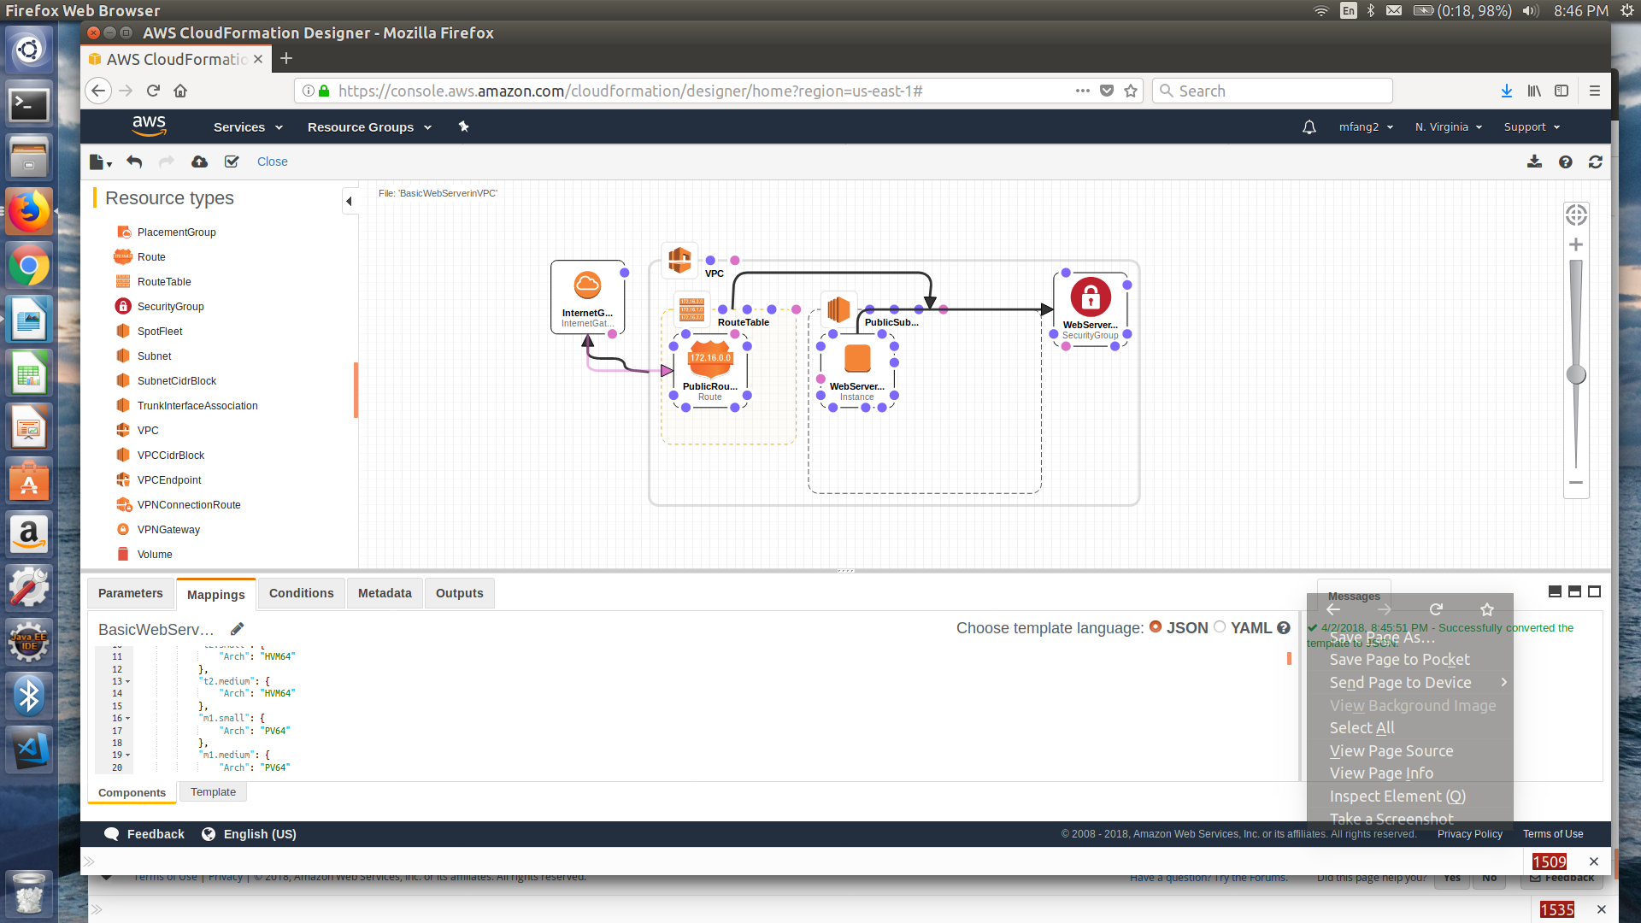

I was attempting to make a template that would work with the EC2 virtual servers that I set up from last week (with Ubuntu 16.04 SSD, since I was having difficulty launching from Red Hat with nginx). Unfortunately the template would not load on stack.

Launch failed due to key mismatch.

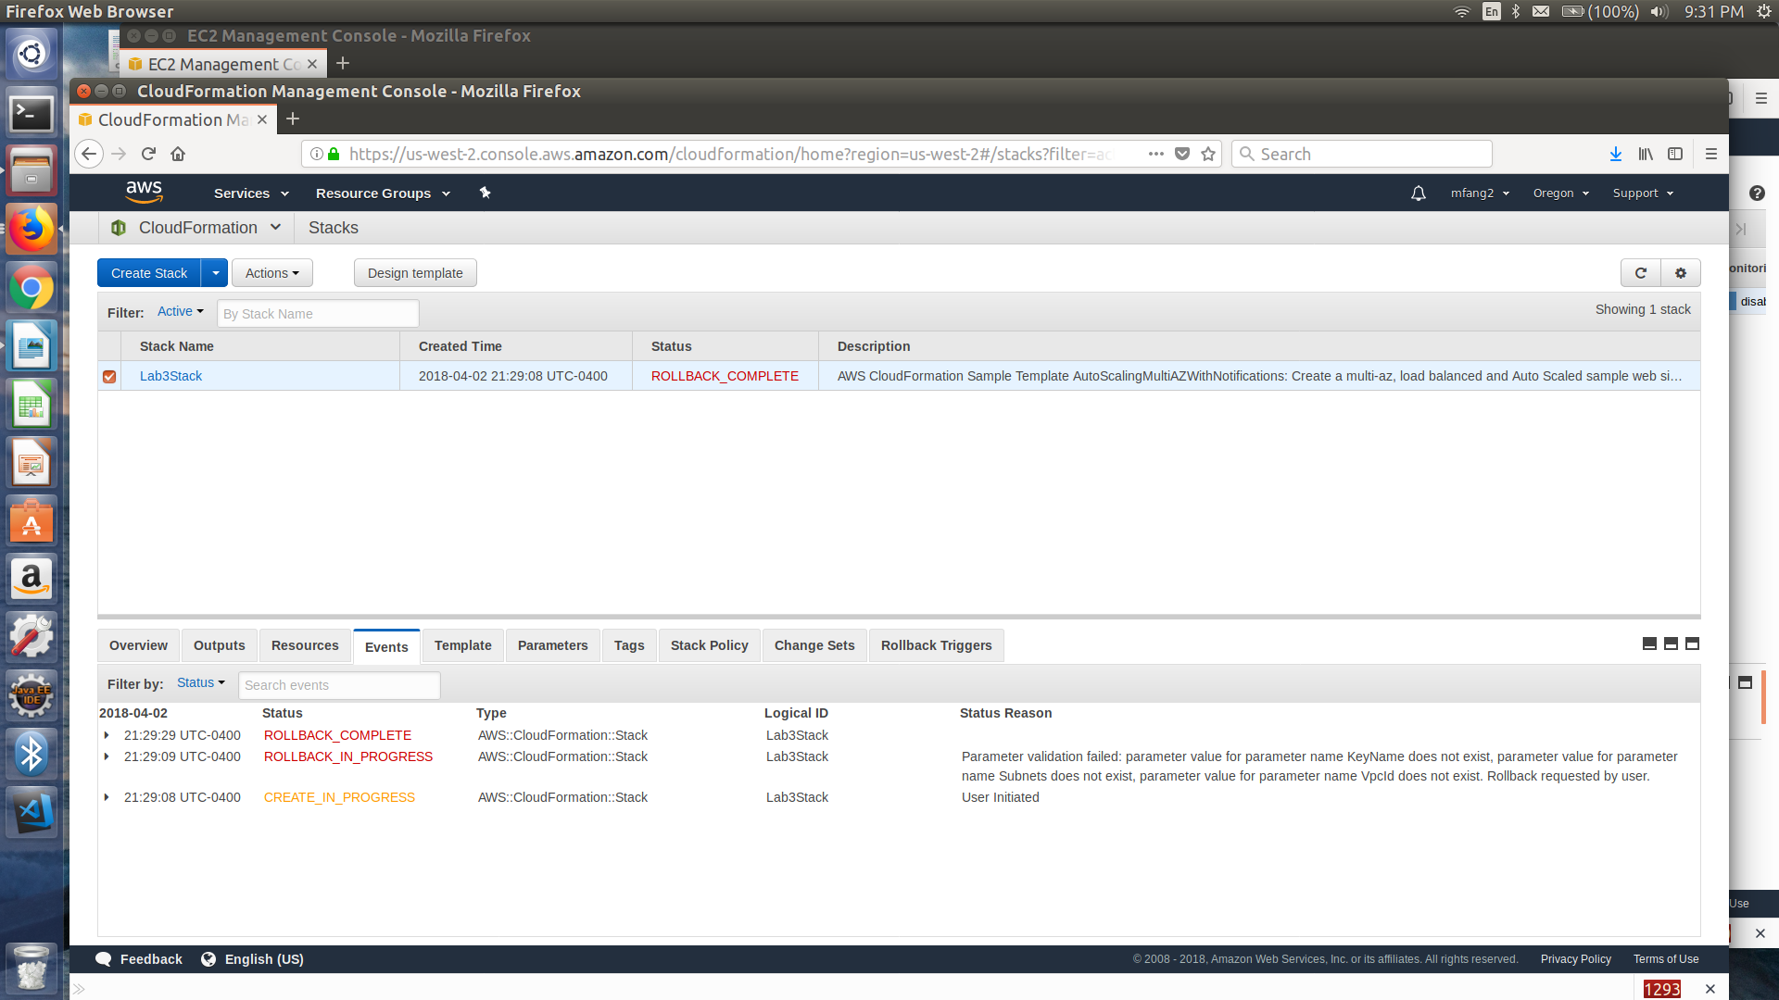

Instead, I used the standard template from the webserver tutorial as described in <https://docs.aws.amazon.com/AWSCloudFormation/latest/UserGuide/working-with-templates-cfn-designer-walkthrough-createbasicwebserver.html>.

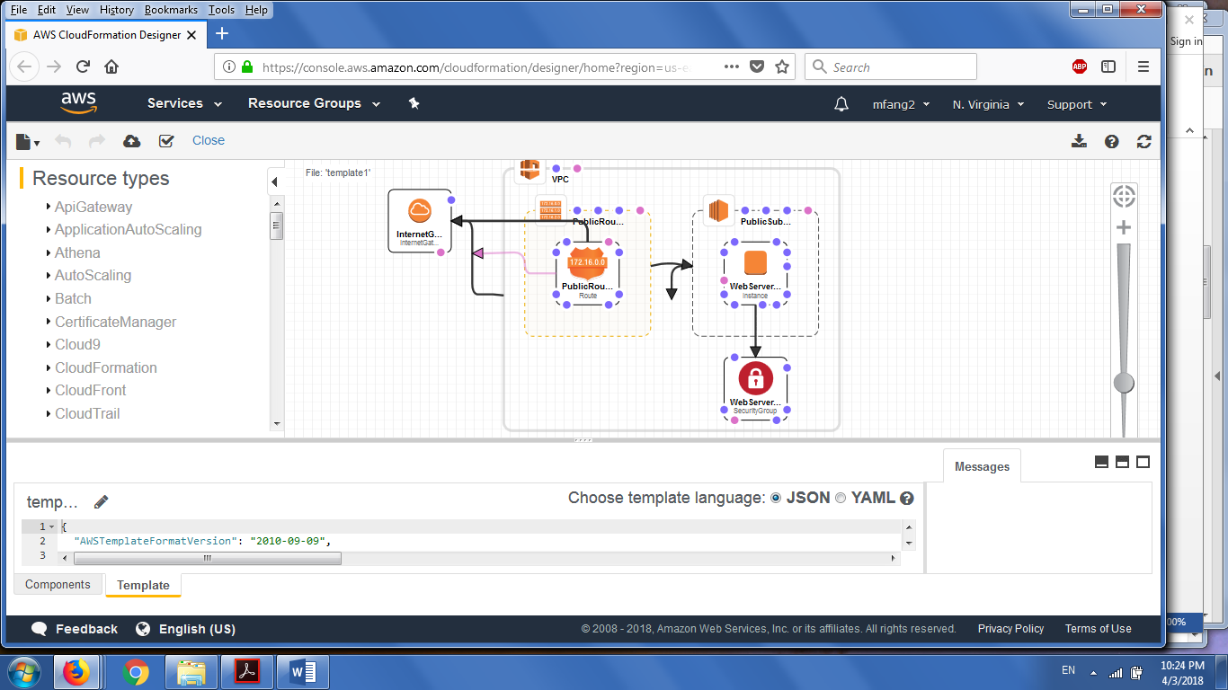

Next I opened Amazon EC2 in console, launched an instance, chose same region for all 5 servers as per last week (security group for SSH, HTTP, and HTTPS, otherwise ngix wouldn’t work in lab 2).

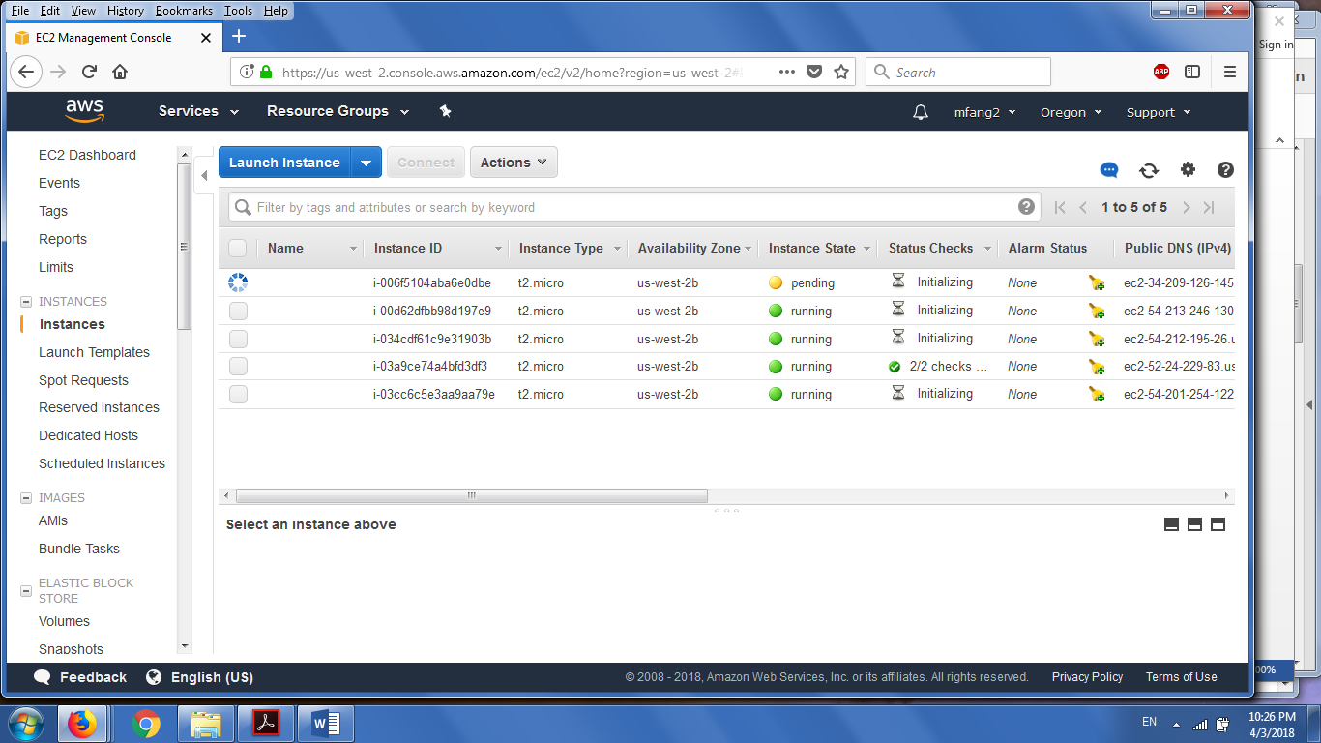

Selecting Load Balancers from the EC2 Dashboard, we create a Network Load Balancer. It is Internet-Facing, with Listener as TCP traffic on port 80 (default). We configure the target group to use any available zone.

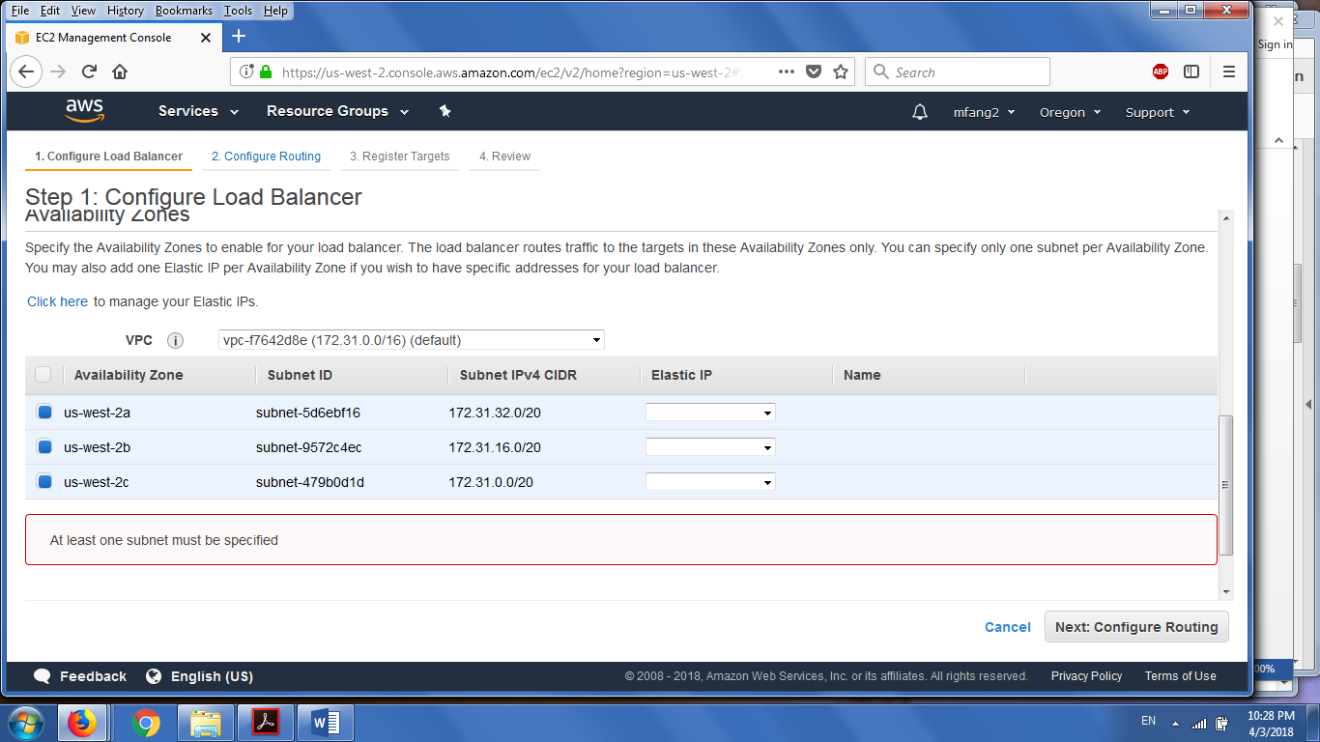

The Routing Targets are all of the servers indicted below

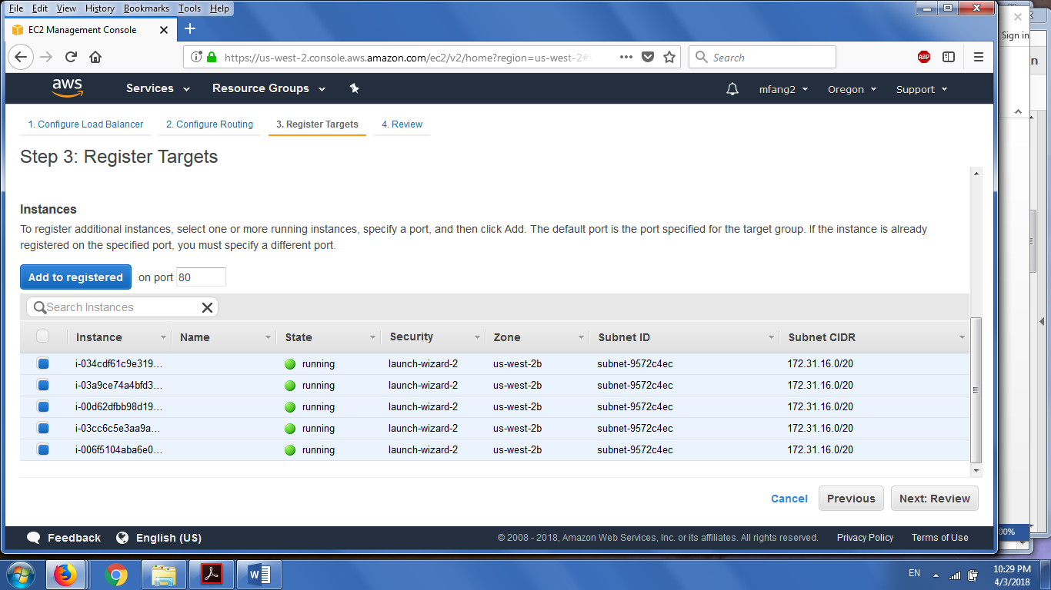

Load Balancer created!

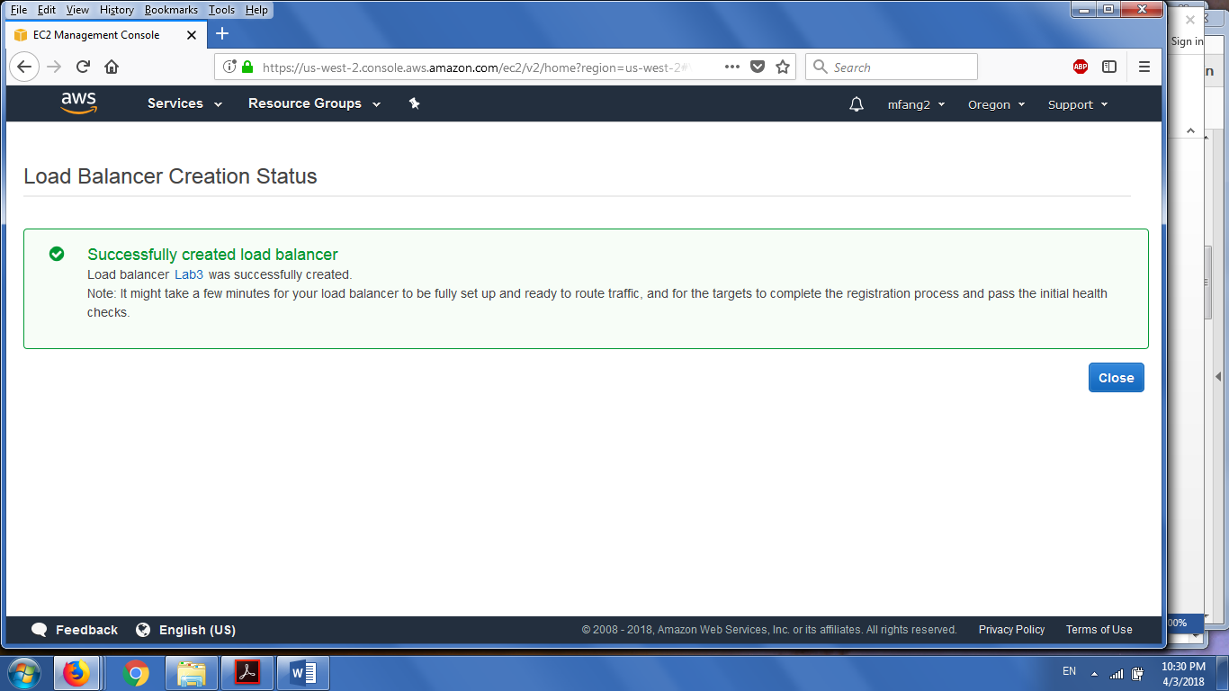

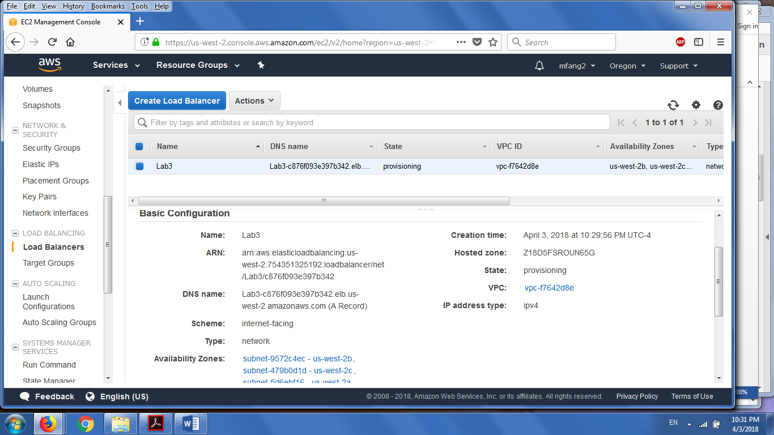

The Load Balancer runs, but unfortunately, for some reason that I have yet to figure out, the DNS would not redirect correctly. Sorry.